Setup Nuxt:

nuxt-communicty/starter-template

create-nuxt-app

npx create-nuxt-app proj-name

yarn create nuxt-app <proj-name>

Update nuxt in starter-template

$ yarn add nuxt@latest

Server:

$ yarn run dev

$ yarn build $ yarn start

$ yarn generate

$ PORT=<port> yarn run dev

For static build ‘generate’ nuxt file must be at server root

Nuxt.config.js:

All Head settings here

Page Setup: config.js / layout / page / component

Default.vue / page.vue / component.vue

CSS: Global – layouts / default.vue

In Vue: Nuxt:

Main.js nuxt.config.js

App.Vue layouts / default.vue

Pages pages

Store Store

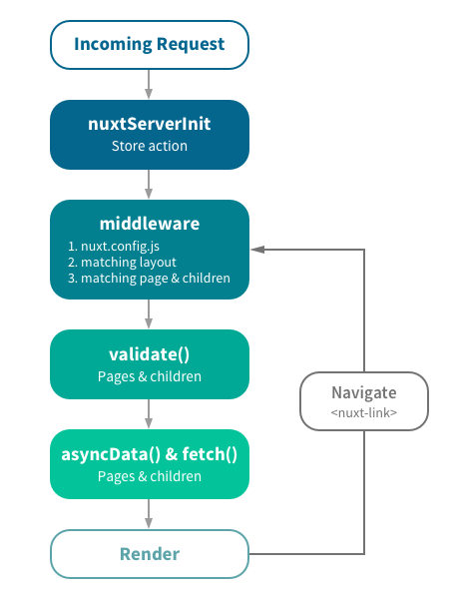

Universal Header / Footer

Default.vue

Header div

Main div – nuxt

Footer div

Position Header and Footer with

Absolute position, and give Header and Footer

High Z value

Give Main div Padding top and bottom to avoid

Being covered

Error Page in layouts not pages

Nuxt loads every layout file in alphabetical order

Reivew

As an enhanced version of Vue, Nuxt has more functionalities and is also easier to configure. With Nuxt, you can code less but do more.

You don’t have to be a Vue expert to study Nuxt. Just basic Vue knowledge is enough.

Before starting your Nuxt study, we strongly recommend you watch the first section where we show you how to create a Vue app using Vue CLI 3.

You might think this is a waste of time. But you will soon benefit from it.

Nuxt has a very close connection with Vue CLI 3.

The file structure created by Vue CLI 3 is very similar to the one used in Nuxt. They even have the same mechanism of generating pages.

Your previous Vue knowledge can help you quickly understand the working mechanism of Nuxt. Once you have understood how Nuxt works, you can master it in no time.

First, we set up Nuxt. We have two options here.

The first one is the starter template. The full command is:

**vue init nuxt-community/starter-template your_project_name**

This method has been removed from the manual but it still works. Actually, for beginners, the starter template is the best option.The nuxt program it creates is very pure, meaning it contains no third-party plugins or modules. For beginners, this means a less challenging start and more opportunities to learn and practice.

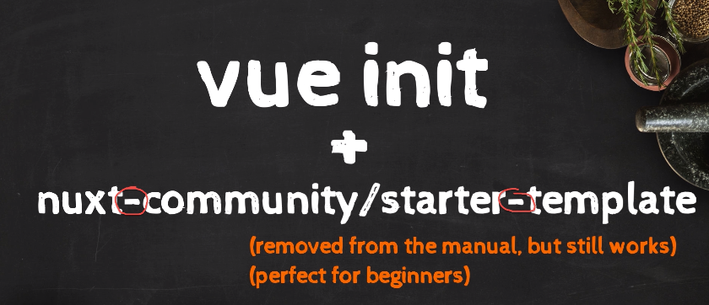

The starter-template

The second method is the nuxt scaffolding tool: create nuxt app.

It is currently the manual’s recommended installation method and it works in both npm and yarn.

The full command is:

**npx create-nuxt-app your_project_name**

You can also run it using yarn. Just remember to remove the hyphen.

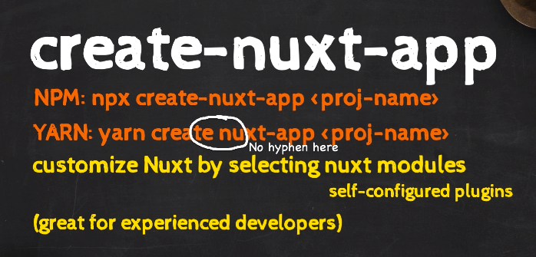create-nuxt-app

The new method allows us to customize nuxt by selecting nuxt modules. Nuxt modules are plugins can configure themselves. You will learn more about this later.

For experienced developers, the module-selecting feature is great. It can save them lots of time and effort. But as beginners, you should not rely too much on it. You must know how to install and configure modules manually.

Let’s create our first Nuxt program. We will use the first method: starter-template.

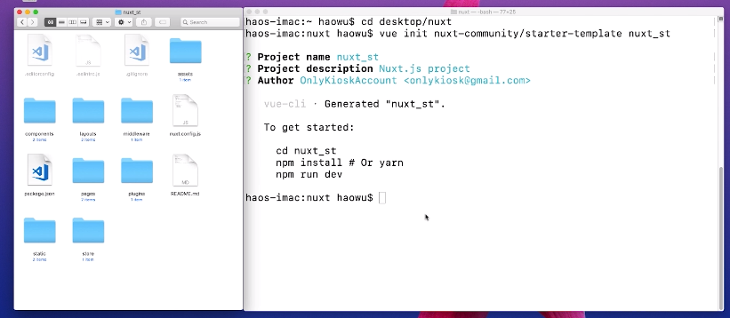

The Nuxt version is 2.0. We need to update it to the latest version.

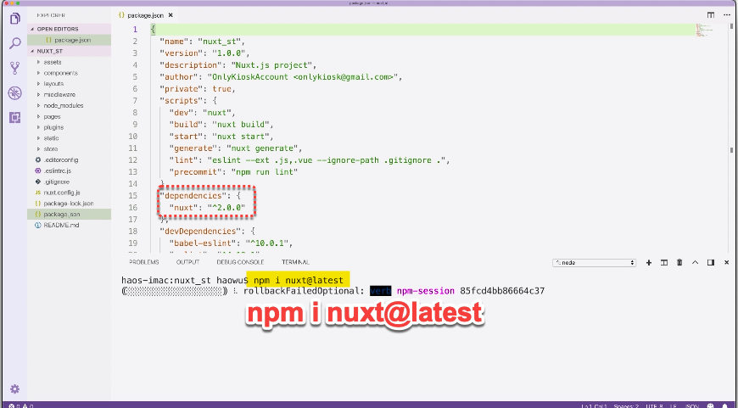

After the installation is done, your Nuxt version should be no lower than 2.4.

In scripts, we have three commonly used commands: dev, build&start, and generate.

The dev command turns on the dev server.

The build and start command work together. You build first, then you start. These two commands turn on the production server.

If you want to host your Nuxt program statically, you use the generate command. But do remember certain functionalities cannot work under the static mode.

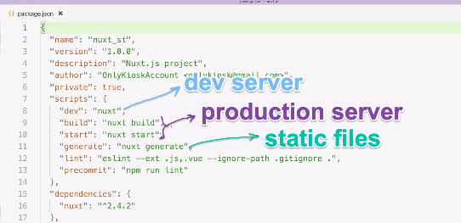

By default, the dev server is hosted at port 3000.

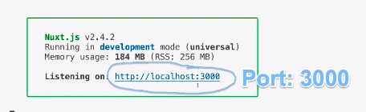

You can reset port using PORT=new port number. You set it in two places:

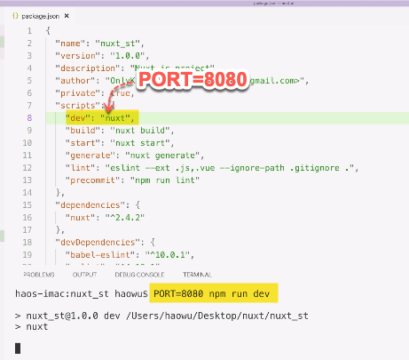

Now, the dev server will move to the new port.

Also remember that PORT must be fully capitalized and there must be NOT whitespace.

Next, let’s try the new method: create-nux-app.

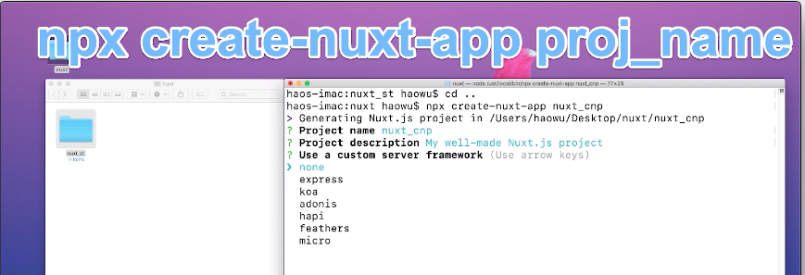

The new method allows us to customize Nuxt.



For experienced developers, this is great. But for beginners, this means more challenges and less practicing opportunities.

We also need to update Nuxt manually:

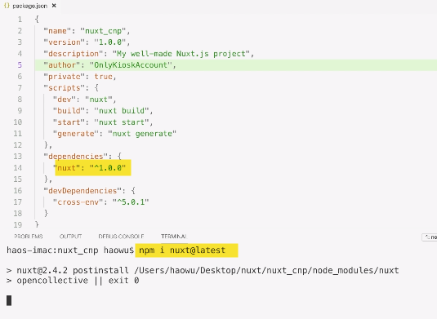

Next, let’s take a look at how Nuxt generate pages.

We will use the default homepage as example. First we turn on its source code.

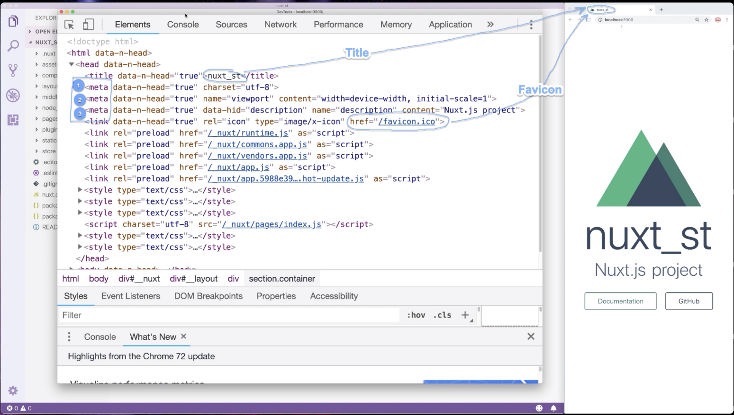

So who sets all the head info?

Open nuxt.config.js, you will find your answer.

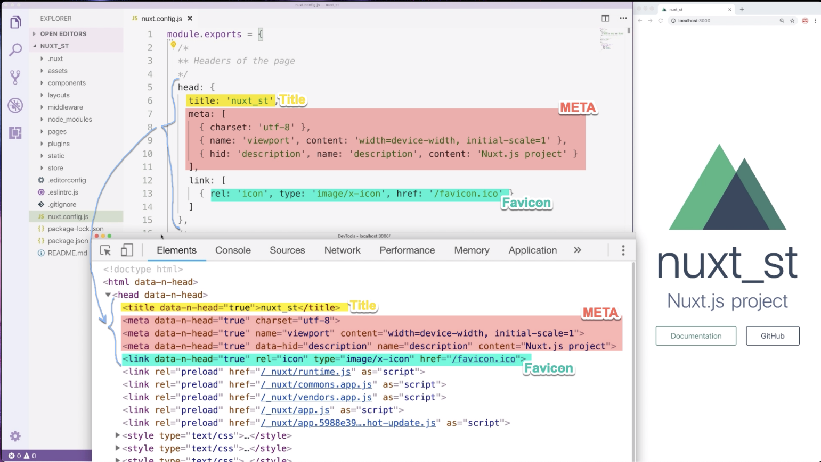

All head info comes from the head object.

Next, we open the body tag.

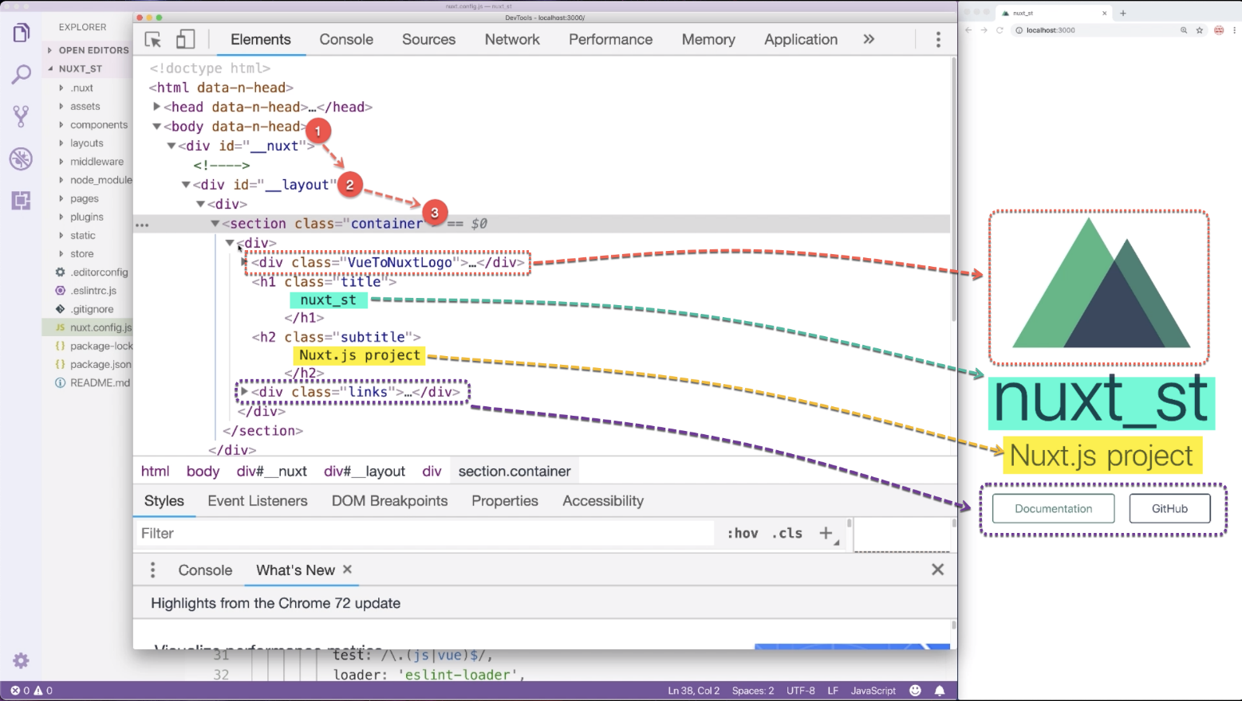

We can see all page elements are wrapped in three parent DIVs: _nuxt, _layout and container.

If we submit an incorrect page address, we will get the default error page. The error page does not have the #container DIV.

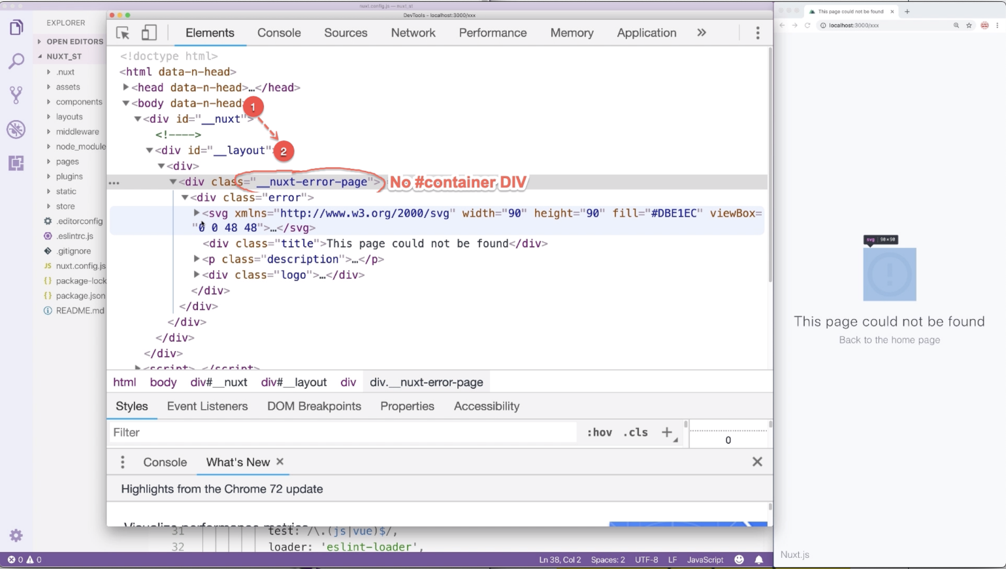

Let’s go to the pages directory and open the only file in it: index.vue.

We can see the #container DIV is created here. The animating logo is created by AppLogo.vue from components.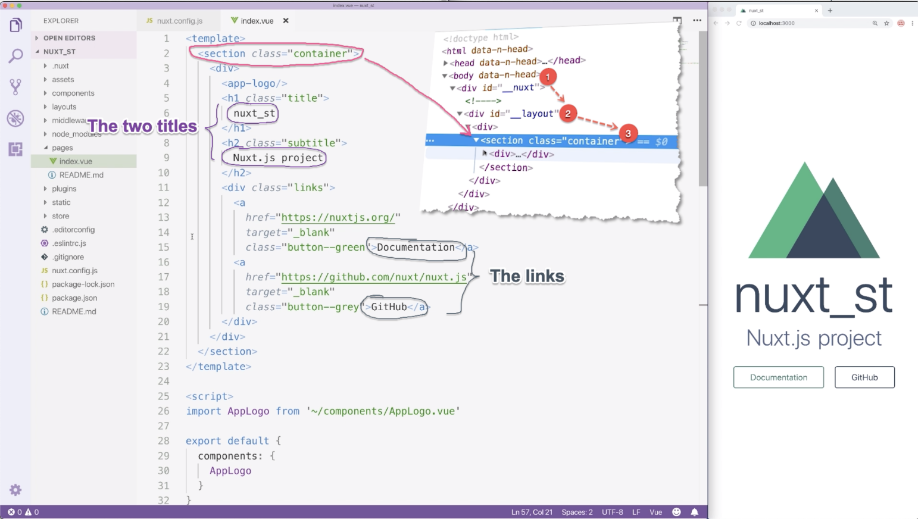

Below the two page titles, we go two buttons. They are created by two A tags.

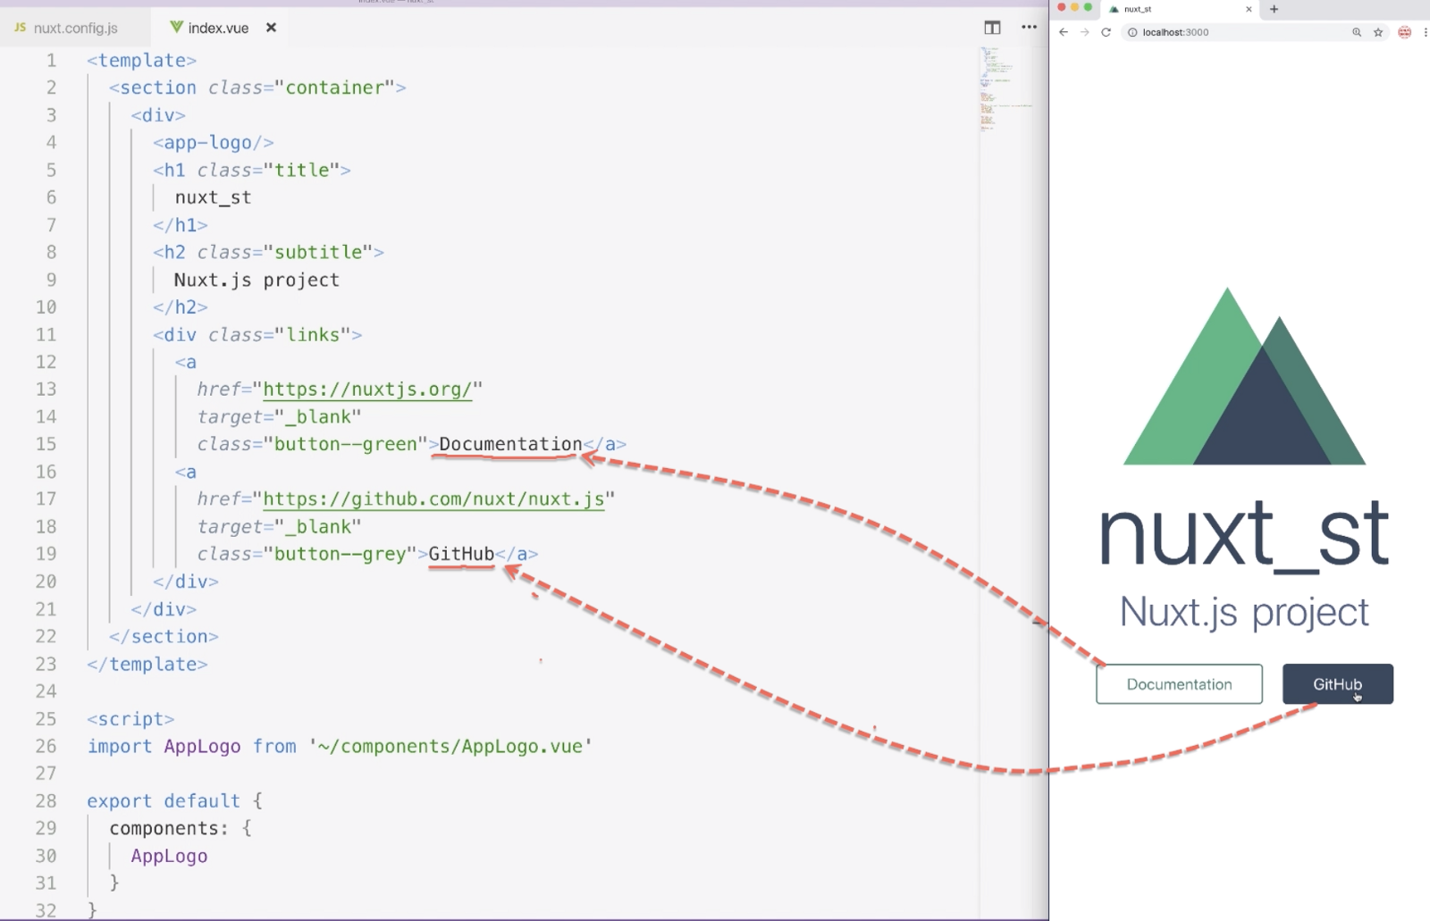

CSS codes in index.vue only set a top padding for the two A tags. So where do they get their styles?

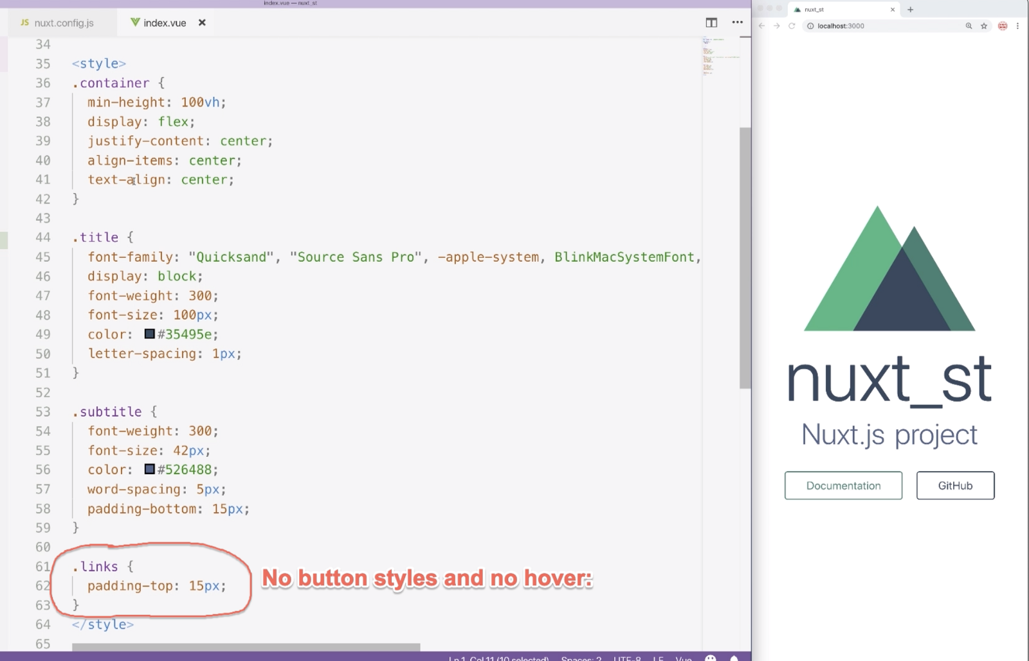

Go to the layout directory and open default.vue, you will find your answer.

The two A tags are styled by layouts/default.vue.

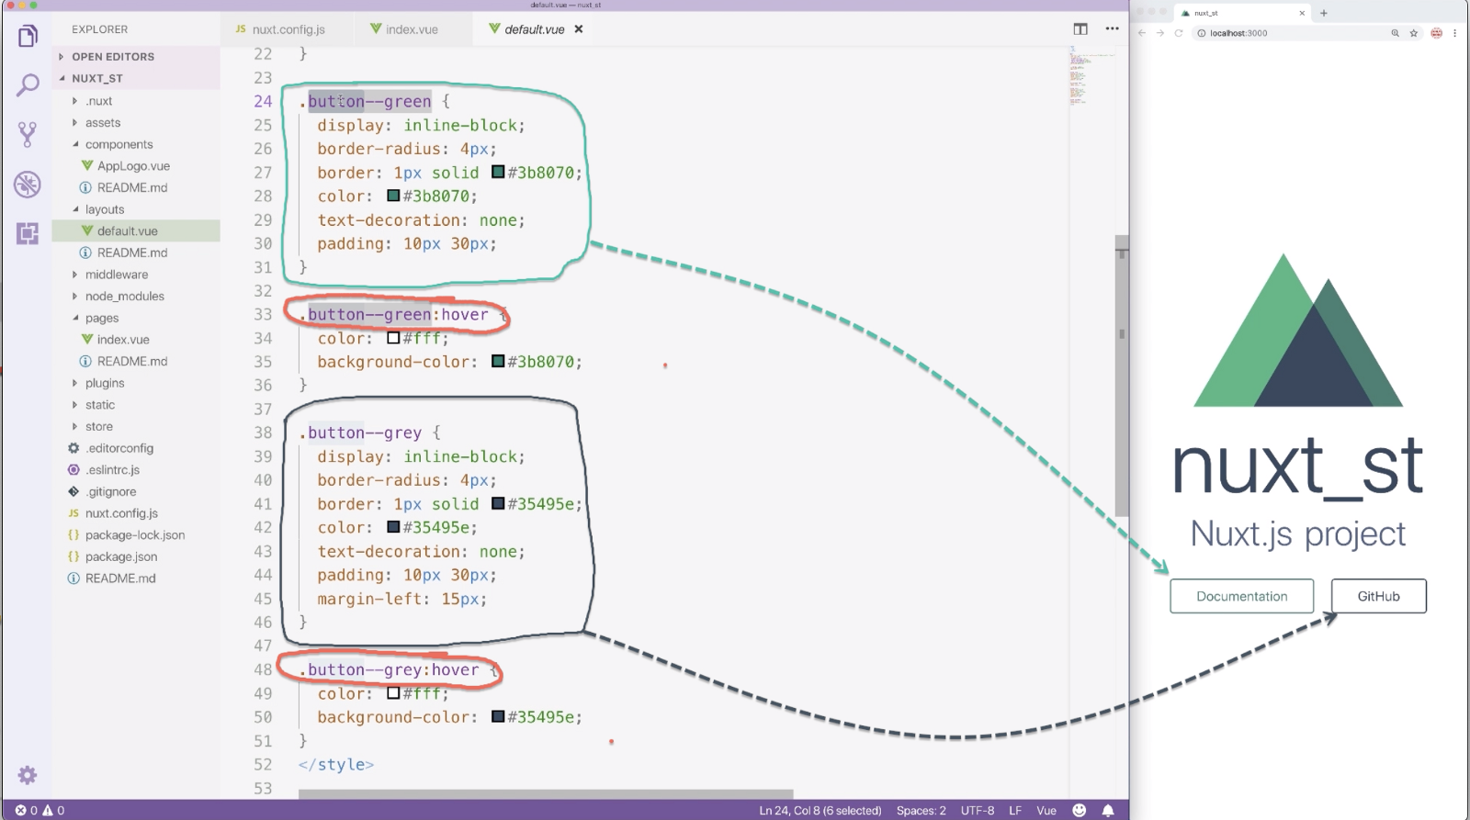How the two buttons are styled

In the template part of default.vue, there is a <nuxt/>.

<nuxt/> is the Nuxt equivalency of <router-view/> in Vue. Files from the pages directory are displayed through it. This is how the two A tags get their CSS styles.

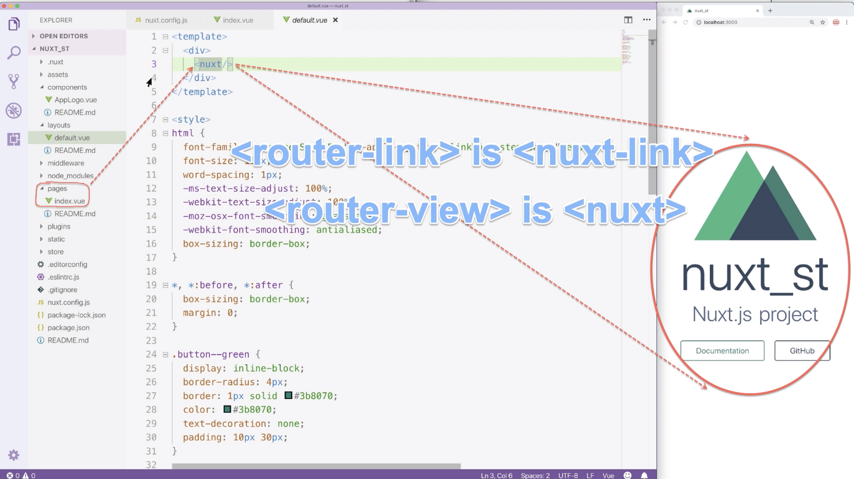<nuxt/>

**Summary:**

A Nuxt page is created by three nesting components.

The innermost components come from the components directory.

The outmost component comes from the layout directory.

Files in pages create virtual pages which are displayed through <nuxt/> in layout files.

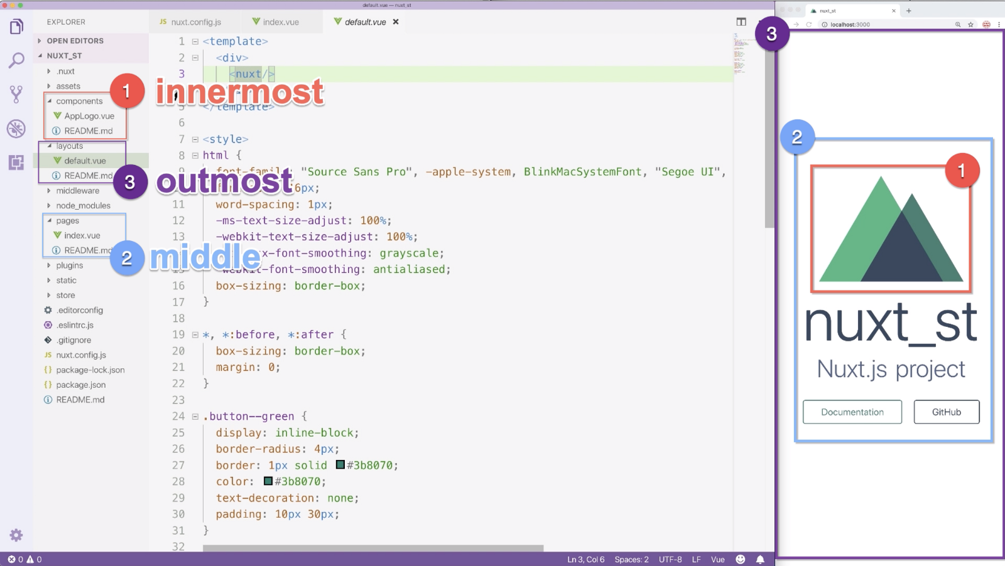How a nuxt page is generated…

Now, we have tried nuxt.config.js, layouts, pages and components.

Nuxt has several other directories. Below is a comparison between Nuxt and Vue.

Basically, in terms of file structure, Nuxt and Vue are basically the same. Look at the image below. Yellow dots represent JS files and green dots represent vue files.

Both Vue and Nuxt have four yellow dots and three green dots.

They use the same page-generation mechanism:

1. App.vue in Vue equals to layouts in Nuxt
2. views in Vue equals to pages in Nuxt
3. components in Vue equals to components in Nuxt.

In terms of JS files, there are only TWO differences:

1. Nuxt does not have the router directory.
2. Nuxt has a middleware directory which does not exist at the Vue side.

Take a close look at the image below. It can help accelerate your future Nuxt study.

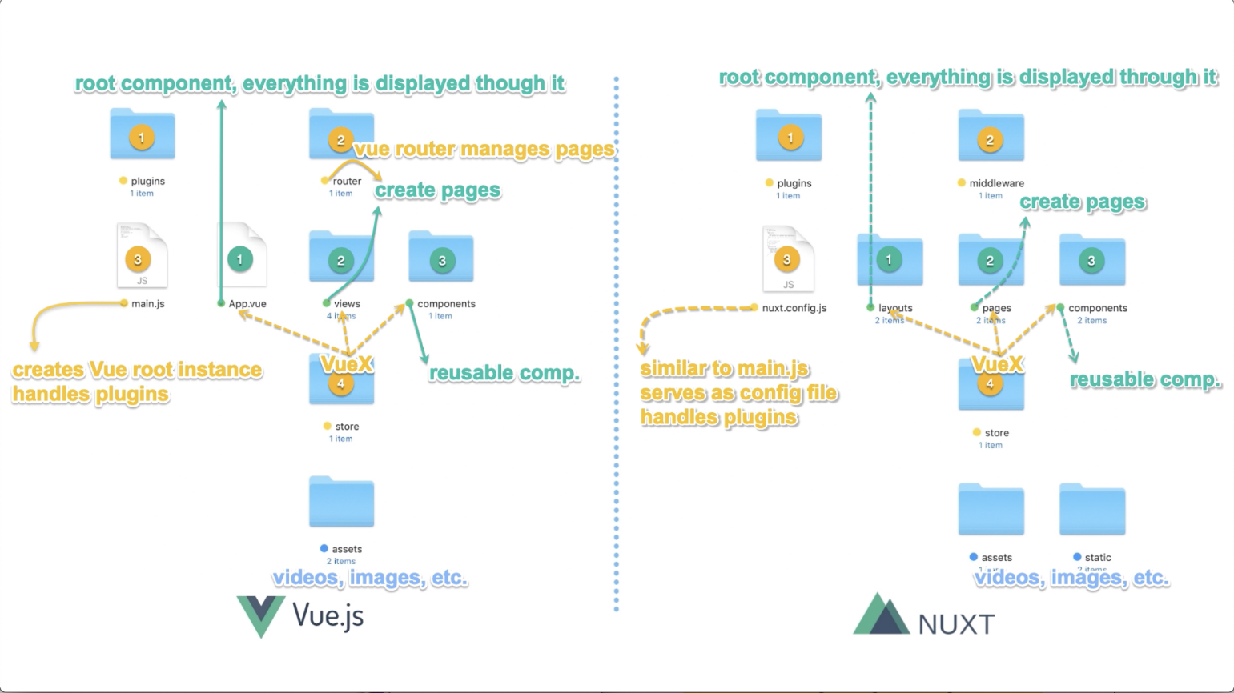

**Application: the HMF Page Structure**

Since all pages are displayed through <nuxt/> in pages/default.vue, if we want set universal elements that will be inherited by all pages, pages/default.vue is definitely our best choice.

For example, we can set a universal header and footer in default.vue. We sandwich <nuxt/> with the header and footer. All pages will automatically inherit the header and footer.

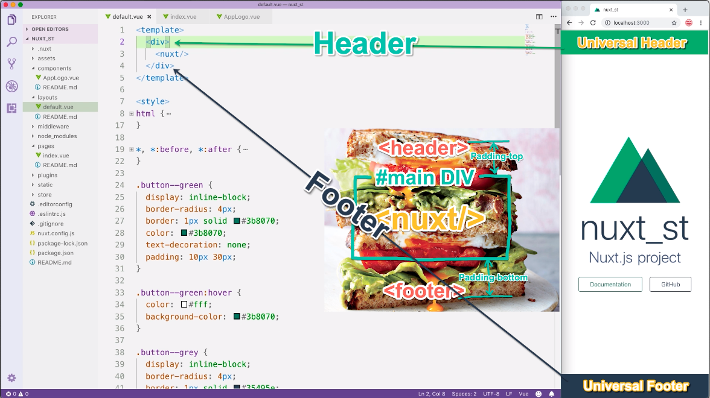

The header and footer are located using absolute position. To protect <nuxt/> from being blocked, we wrap it with a main DIV and give the main DIV a top and bottom padding. As shown below:

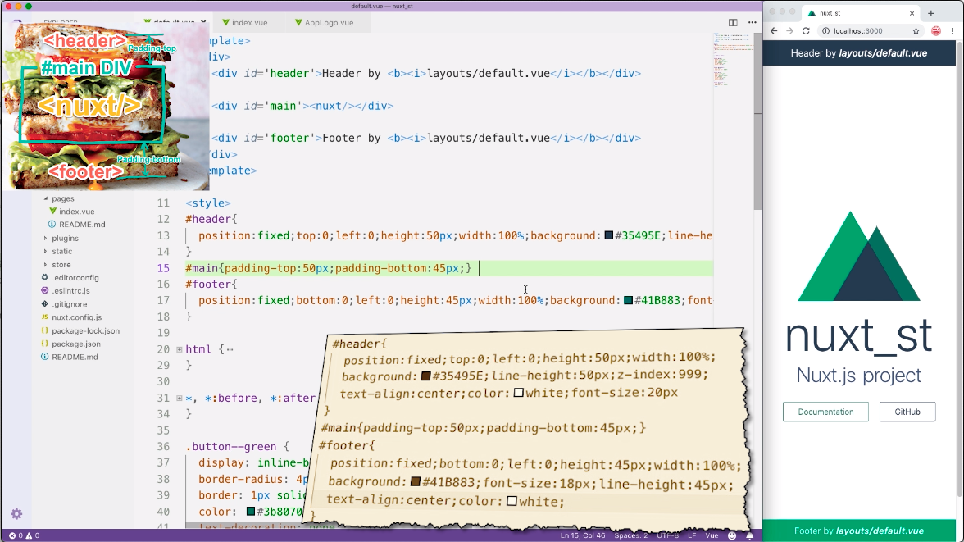

Nuxt offers us a default error page which looks like this:

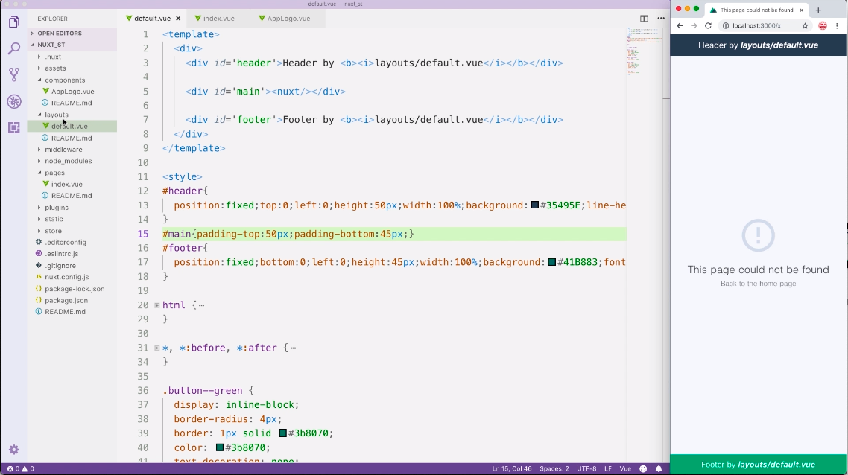

We can create our own custom error page. But unlike normal pages, the error page is defined in the layout directory and the file name must be error.vue. Do remember this.

The error page relies on the error prop to receive error info. So remember to declare the error prop if you want to display error info.

The value of the error prop is an object. It contains two properties: message and statusCode.

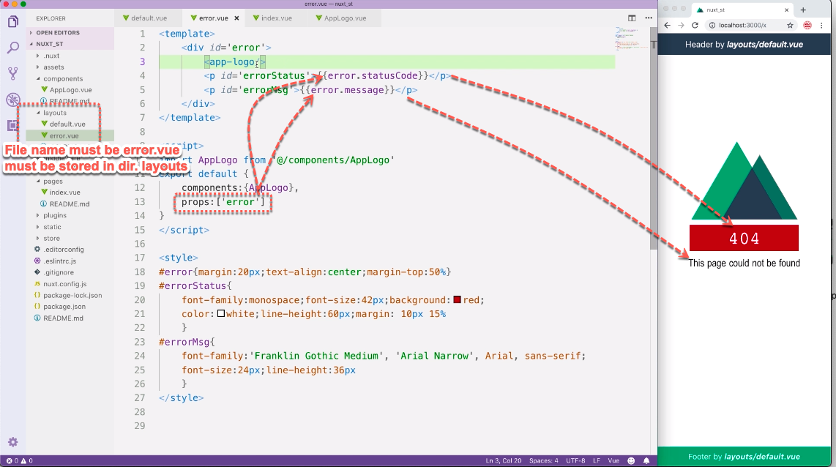

The error page will inherit the default layout file. We can create a custom layout for it.

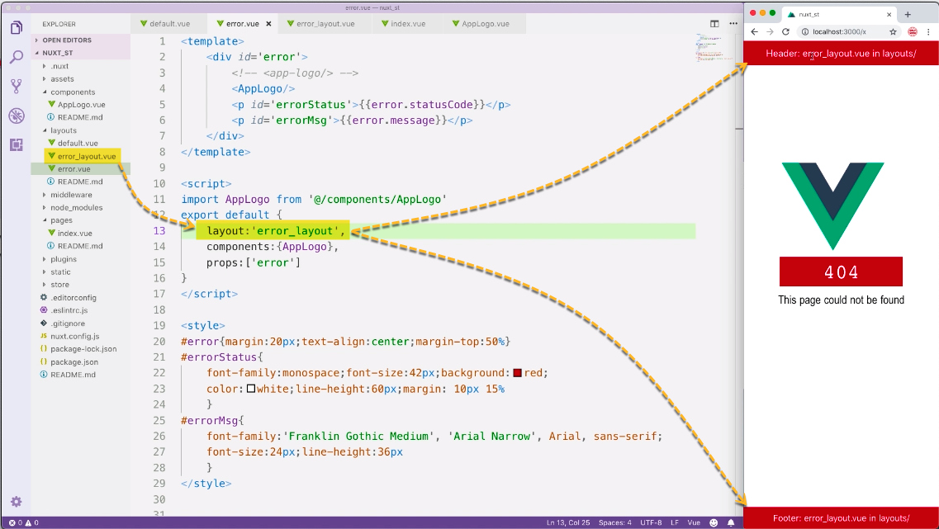How into install custom layout

All layout files, used or unused, will be loaded. This means CSS codes from all layout files will be loaded. This will cause CSS pollutions.

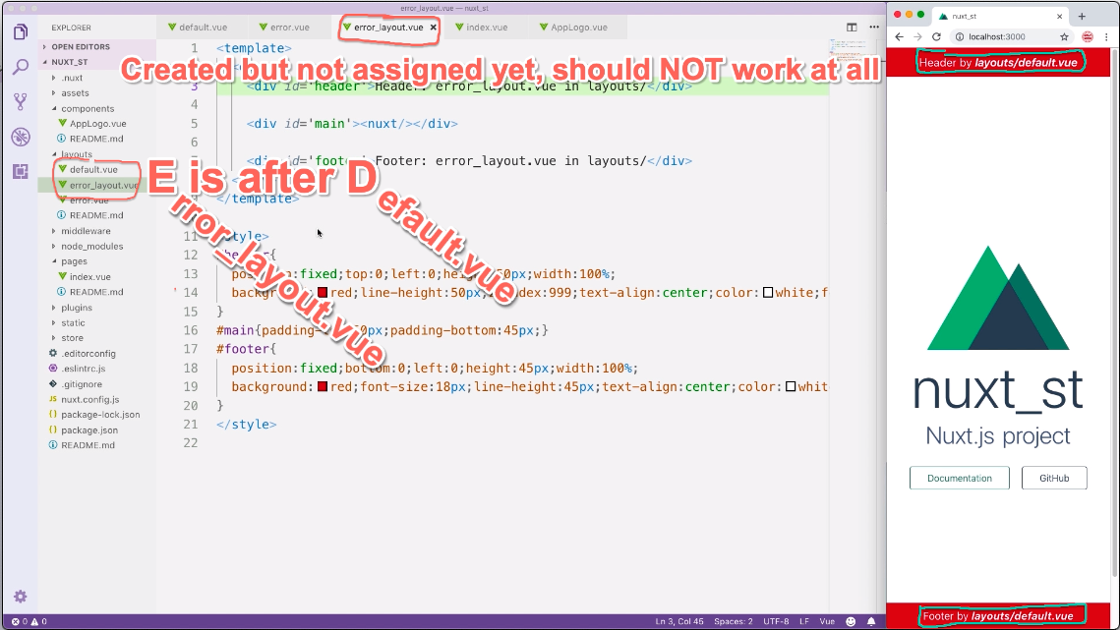

To prevent CSS pollution, remember to scope the style tag in all layout files.

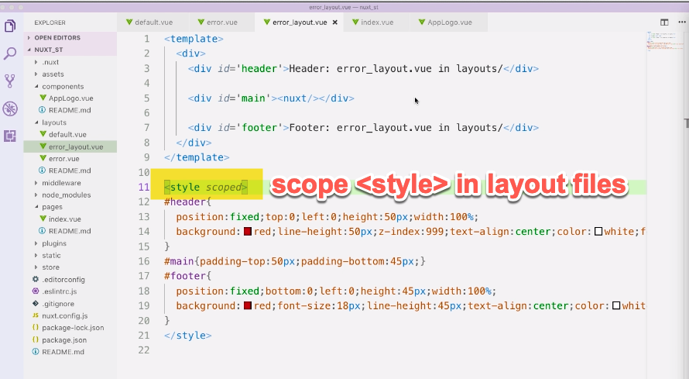

Review

**Universal CSS and CDN**

In Nuxt, creating a universal CSS file that will be inherited by all .vue files is very simple. Just record the file path in the nuxt config file.

You create the CSS property and assign an array to it. File path is the array element. @ and ~ represent the root directory.

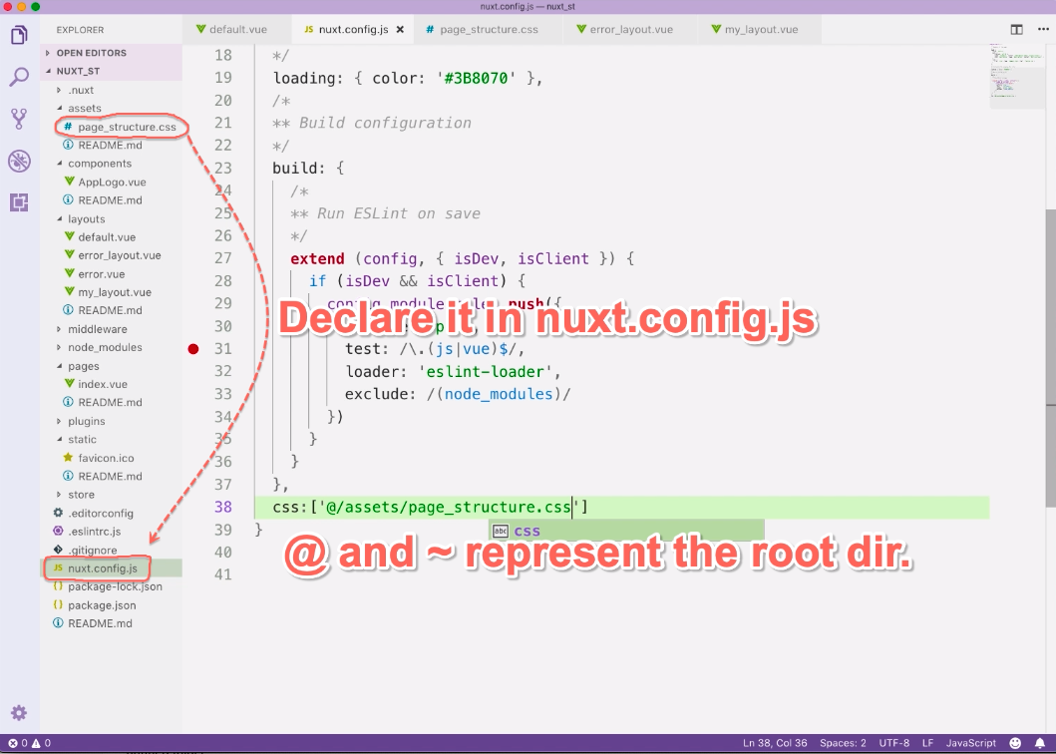

The CSS property can only be used to declare local universal CSS files. If you want to use CDN, you need to go upstairs and find the head property.

For example, we want to install font awesome via CDN.

We go to the head obj and find the link array.

We add a new obj. as element and set the CDN there.

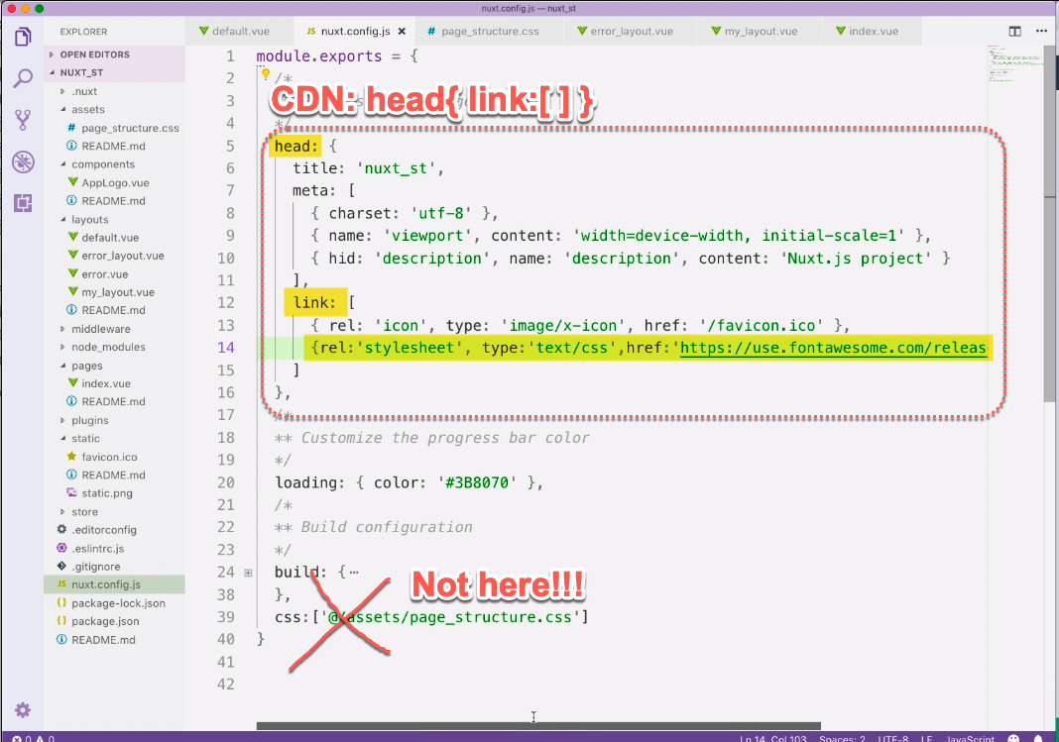

**Assets Vs. Static**

Next, let’s learn the difference between assets and static.

We have prepared two images: asset.jpg and static.png. We will display them in our Nuxt program.

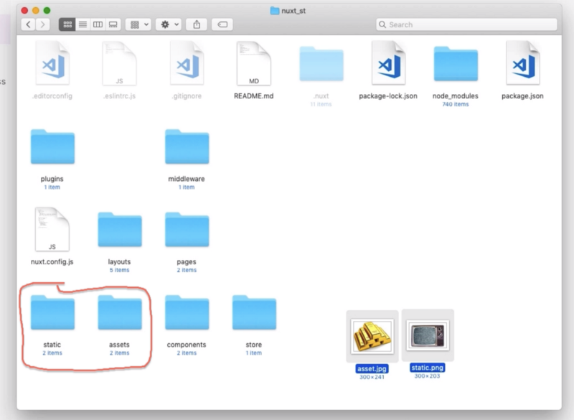assets VS. static

If you want to display an assets file, use the absolute path.

But if you want to display a static file, use slash and file name.

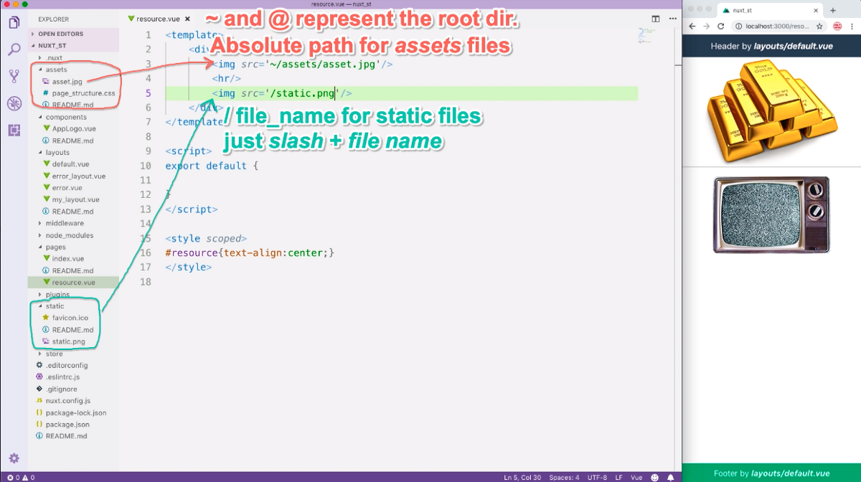

When you are displaying an assets image from CSS, make sure you use ~assets/file name. The slash between ~ and assets should be removed and you must use ~. You CANNOT use @.

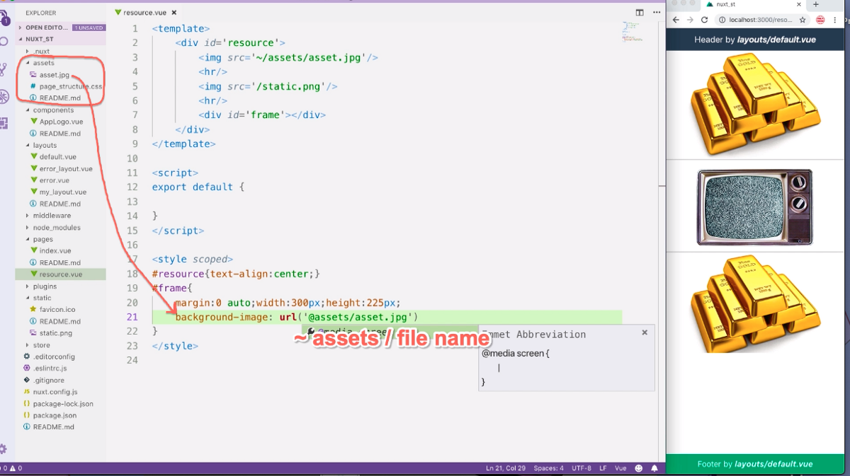

Assets files cannot be linked dynamically. Do remember this.

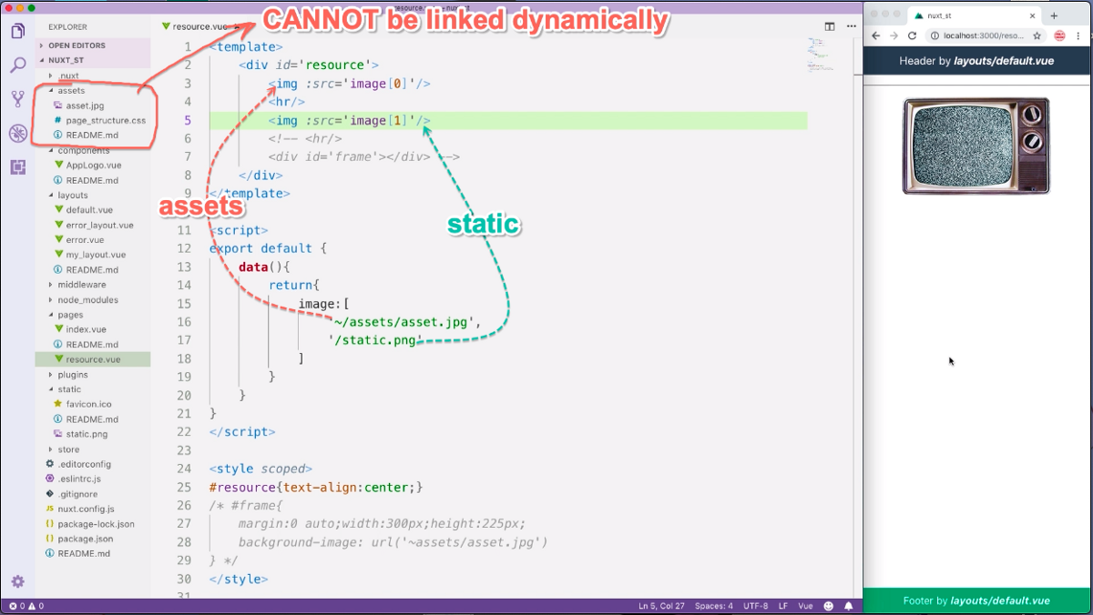

A little summary here:

The difference between ***static*** and ***assets*** is how they are handled by Webpack.

Webpack will directly bundle static files into the dist folder and keep their original names. This is why we can link static files using slash file name.

As for assets files, things are more complicated. They will be handled by corresponding loaders. They will be renamed and bundled into underscore Nuxt. If you have files that need to be compiled, for example, sass, less, es6, you should put them in assets.

If you need to link asset files from CSS, remember to use tilde and remove the slash behind it. Also remember you cannot link assets files dynamically.

**UI Module: boostrap-vue**

Nuxt module is basically a pre-defined plugin. We are saved the trouble of creating the config files.

We will use bootstrap-vue as example. We install it in NPM.

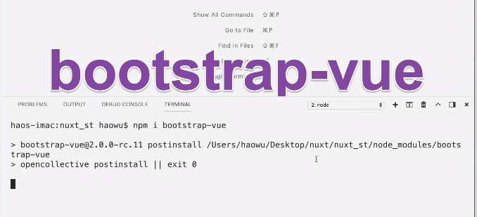

Then we first configure it as a normal plugin.

In the plugins directory, we create a new JS file: bootstrap.js. It will works as the bootstrap config file.

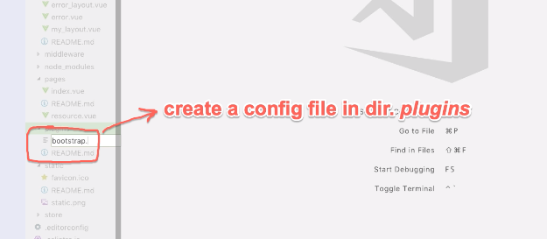

The content of the config file can be copied from the manual. After the config file is done, we register its file path in the nuxt config file.

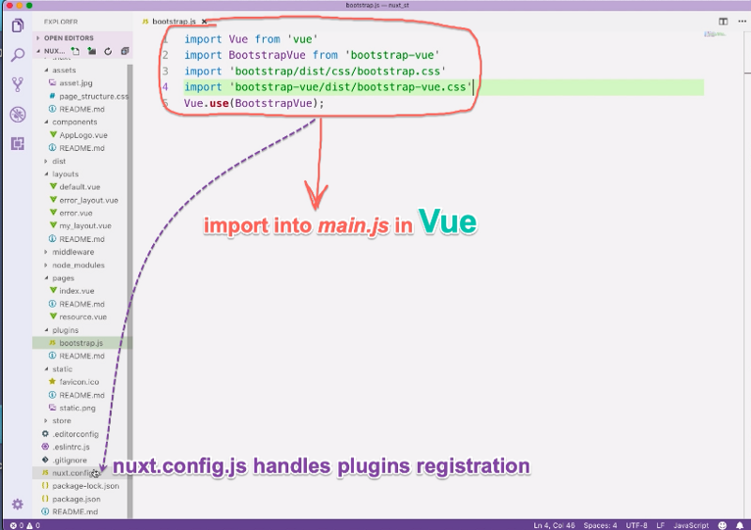

In the nuxt config file, we create a new property: plugins. Its value is an array.

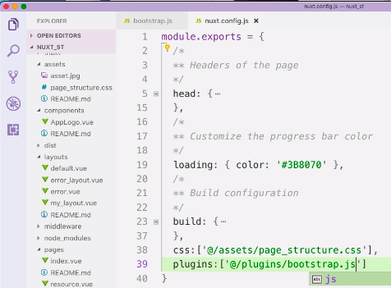

Now, bootstrap has been configured as a plugin.

If we wan to install Bootstrap as a nuxt module, there is no need to create the config file. All we need to do is to register the module in the modules array. As shown below:

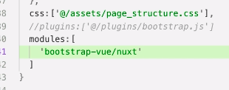

**Setting HEAD info using the head method**

At this moment, our Nuxt program has three pages: the homepage, the resource page and the UI page.

All these three pages have the same title. This is because they all inherit the same head setting from the nuxt config file.

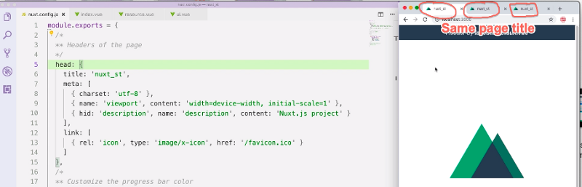

We can set a custom head info for each page using the head method.

We will start with the homepage.

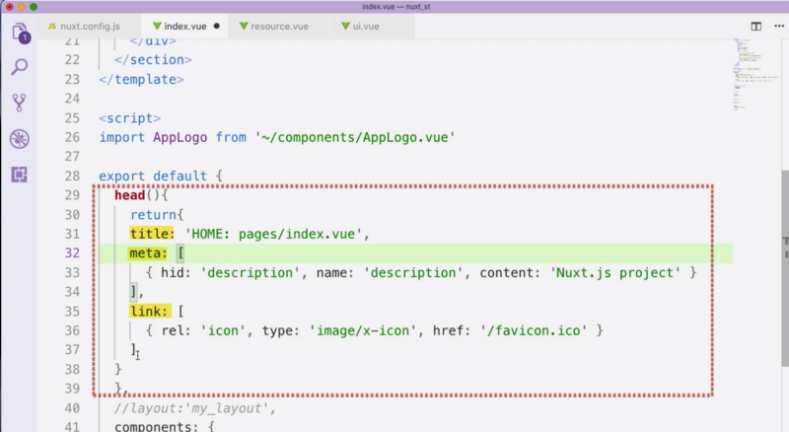

The head method will override the settings from the config file.

hid id very important. It makes sure each page only has one description meta. Make sure you keep it in your head method and also make sure its value is the same as the one used in the nuxt config file.

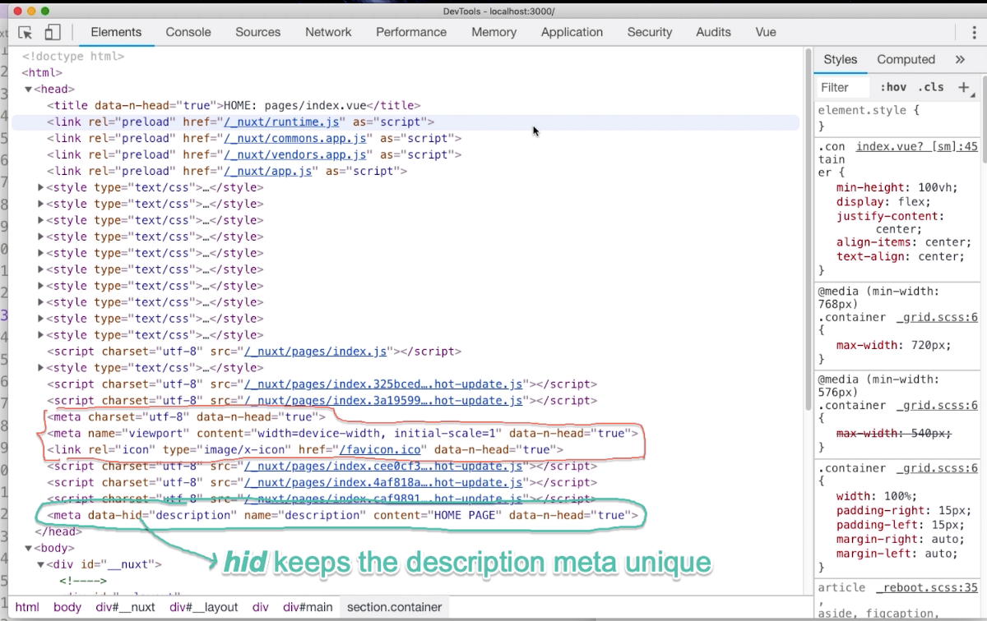

**VueX in Nuxt**

The store directory is where you store all your VueX config files.

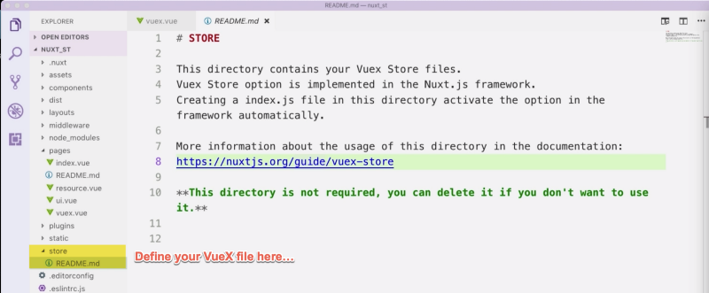

There are two ways you can set the VueX file:

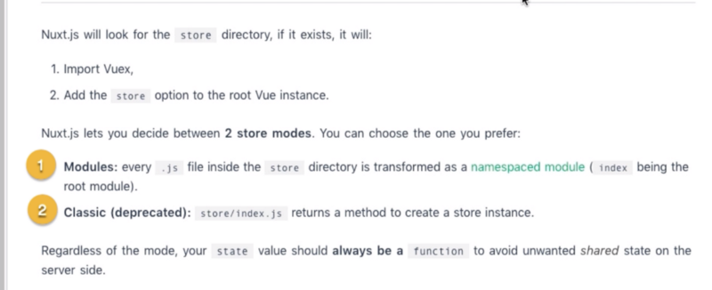

We recommend the first one because it is more convenient. We do not need deal with formalities like importing vuex and instantiating the store method.

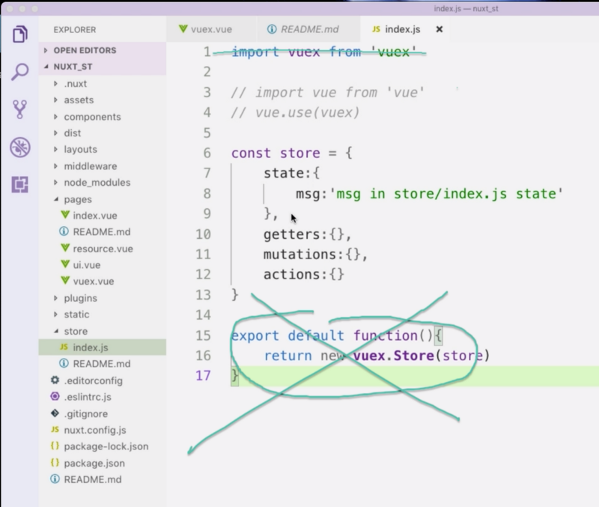

We only need to define state, getters, mutations and actions.

For state properties, we export constant state and assign a function to it. Inside the function, we return an object. All state properties are defined in this returned object.

For getters, mutations and actions, we set constant value to an object.

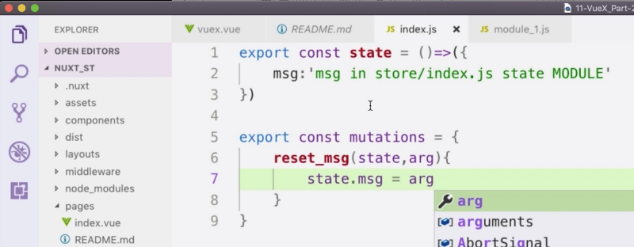

In component template, we can access VueX via $store.

